IKEA Octave Dining Set

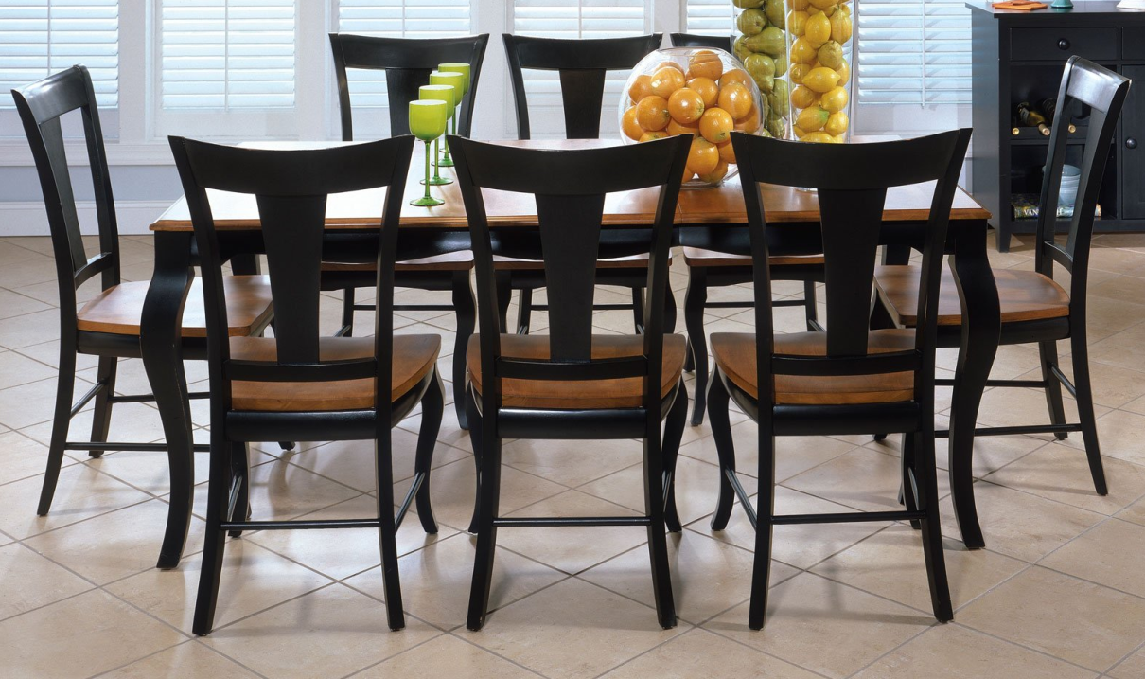

|  |
| --- |
| **DESCRIPTION** |
| IKEA introduces stylish wooden bend finish with dark chocolate color. The set of tables and chairs is perfect to create the perfect look for family gathering. The rich wooden plank gives you feeling of happiness. High pitched gravity balances the chairs so that they do not slip over the ground. Perfect for you and your family. |

|  |  |  |
| --- | --- | --- |
| **Price** | **1600$** | |
| **Dimensions** | **Table H** x **W** x **L** | **45in x 45in x 90in** |
| **Chairs H** x **W** x **L** | **35in x 20in x 30in** |
| **Features** | **Eight Chairs and One Table with wooden sheet attached on top provide a helping hand to lift heavy objects and cutting edge durability.** | |
| **Finished** | **Wooden Draft** | |
| **Available in** | **Brown Only** | |